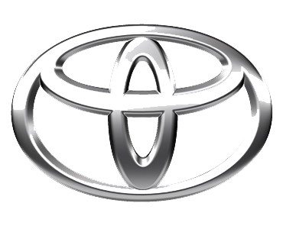
undefined
TOYOTA MOTOR CORPORATION
I. TOYOTA-CHO TOYOTA. AICHI, 471—8571(HEAD OFFICE)
or 471 8572 (Research 5 Development Group) THAILAND
TEL: +81-565-28-212

GSO Conformity Certificate CCR No. 697020
Motor Vehicles
Manufacturer: TOYOTA
Country of Origin: THAILAND, Country of Production: THAILAND
To: GCC Standardization Organization (GSO)
We hereby certify that the vehicles manufactured by TOYOTA
* Type: TOYOTA HILUX GR (GUN126) 2.8L Pick-up 4WD 4Doors
* VlN number: MR0BA3CD*T*******
* Model Year: 2025 * Produced in and after: Month 2 Year 2025
* Category: Truck
Will satisfy the G50 Technical Regulations Nos: 34:20o7, 3s:2007, 36:2005, 37:2012, 38:200s, 392005, 40:2011,42:2015, 48:1984, 51:20o7, 52:2007, 53.2007, 9611988. 9721988, 9811988, 9921988,13522007, 13622007. 29021994. 4119:1994,42o:1994,421:2005,422:200s.1040:20001041:2000,1042:2000,1053:2000,1503:2010,1598:2002,1624:2002,1677:2003,1708:2o0s,1780:2010,1781:2006,1782:2008,1783:2006,1784:2o0e.Gsolso1585:2008,GSO lSO 3537:2008, GSO 150 3538:1997, G50 ECE13H:2012,GSO ECE13H-1:2012,GSO ECE13H-2:2012,GSO ECE 13H-3:2012, GSO ECE13H-4:20l2, GSO ECE13H-S:2012,GSO ECE 13H-6:2012 and the standards in the country of origin accepted by GSO in the case that no GSO technical regulations and standards are available.
All the essential technical data are as follows:
1. Weights
a. Maximum Vehicle Weight: 2810 kg b. Curb: 2035 kg
c. Maximum Axle Weight: Front: 1200 kg Rear: 1750 kg
2. Dimensions
a. Length: 5325 mm b. Width: 1855 mm
c. Height: 1815 mm d. Wheelbase (Fl R1) 3085 mm e. Track: Front: 1540 mm Rear: 1540 mm
3. Type of chassis and body: Body-on-frame
4. Number of Passengers: 5(Including the Driver)
5.Engine: Diesel a. Cylinders: 4 b. Displacement: 2755cc c. Air intake: Turbo
d. Net Engine Power: 149 kW at 3400 rpm Pollutant Limit comply with Euro 6.
6. Transmission: Automatic

7. Brakes a. Service Brakes: Hydraulic b. Emergency Brakes: Combined with the service brake
8. Fuel Economy a. Motor Vehicle Class: Light Truck b. FE (CAFE) Combined: 16.3.7 km/L - Very Good
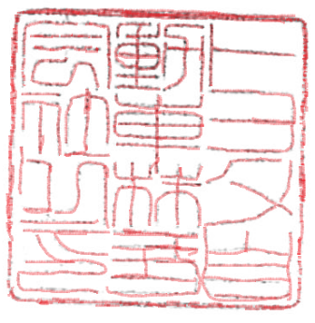
9. Any other information or local standards to be compiled: Also comply with the National regulations for member countries mentioned in the Annex of the list of Technical Regulations for MV 2026 MY-D5, when exporting to those countries. for member countries mentioned in the Annex of the list of Technical Regulations for MV 2025MY-D3, when exporting to those countries. for member countries mentioned in the Annex of the list of Technical Regulations for MV 2025 MY-D3, when exporting to those countries.
Keiko Yanagi
19 FEB 20262025
general Manager Regulation &Certiﬁcation Division

